DAY-1 Hands-On Activities

Problem 1
Assessment Goal: Check if learners understand basic HTML structure and content creation.
Hands-on Tasks:
- Create a basic HTML page with proper structure (DOCTYPE, head, body)
- Add a heading and a paragraph introducing yourself
- Create an unordered list showing your hobbies
- Create an ordered list showing daily routine steps
- Create a simple table showing:
  - Student Name
  - Subject
  - Marks
Expected Outcome:
A static HTML page that displays structured content correctly in the browser.
HTML Code:
<!DOCTYPE html>
<html lang="en">
<head>
<meta charset="UTF-8">
<title>My Basic HTML Page</title>
</head>
<body>

<h1>About Me</h1>
<p>Hello! My name is Sarika. I recently completed my B.Tech.</p>

<h2>My Hobbies</h2>
<ul>
<li>Reading Books</li>
<li>Dancing</li>
</ul>

<h2>My Daily Routine</h2>
<ol>
<li>Wake up at 6:00 AM</li>
<li>Attend classes</li>
</ol>

<h2>Student Marks</h2>
<table border="1" cellpadding="5" cellspacing="0">
<tr>
<th>Student Name</th>
<th>Subject</th>
<th>Marks</th>
</tr>
<tr>
<td>Sarika</td>
<td>Mathematics</td>
<td>90%</td>
</tr>
<tr>
<td>Sarika</td>
<td>Computer Science</td>
<td>93%</td>
</tr>
<tr>
<td>Sarika</td>
<td>English</td>
<td>90%</td>
</tr>
</table>

</body>
</html>

Output:
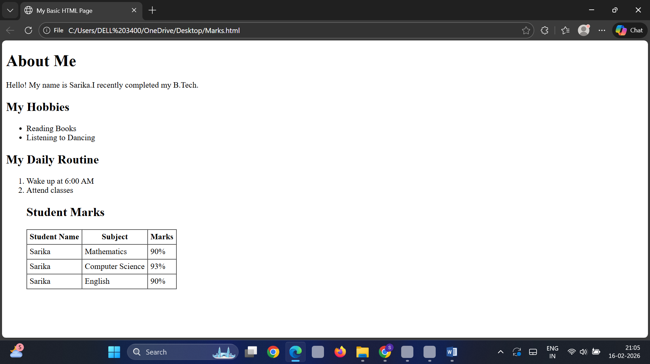
Explanation:
This HTML document is created to demonstrate the basic structure of a webpage using proper HTML boilerplate including <!DOCTYPE html>, <html>, <head>, and <body> tags. The page contains a main heading and a paragraph introducing the student. An unordered list (<ul>) is used to display hobbies, and an ordered list (<ol>) is used to show daily routine steps in sequence. A table is created using <table>, <tr>, <th>, and <td> tags to display student name, subject, and marks. This webpage successfully shows structured content clearly in the browser.
Problem 2: Restaurant Menu Webpage (Level-1)
Scenario
A small restaurant wants a basic menu webpage to display their offerings online before moving to a full website.

📌 Requirements
Create an HTML page that displays:
- Restaurant Name (Heading)
- About the Restaurant (Paragraph)
- Menu Categories (Unordered List)
- Price List (Table)

📋 Table Structure
Item Name | Category | Price (₹)
Paneer Butter Masala | Main Course | 220
Veg Biryani | Main Course | 180
Masala Dosa | Breakfast | 90
Cold Coffee | Beverages | 120

🛠️ Technical Constraints
- Use proper HTML boilerplate
- Use at least 5 HTML elements
- Use HTML attributes such as border, title, align
- Use:
  - <table>, <tr>, <th>, <td>
  - <ul> and <li>
🎯 Learning Outcome
You should be able to:
- Build a complete HTML page structure
- Use tables for structured data
- Use lists for grouped information
HTML Code:
<!DOCTYPE html>
<html lang="en">
<head>
<meta charset="UTF-8">
<title>Spice Garden Restaurant Menu</title>
</head>

<body>

<!-- Restaurant Name -->
<h1 align="center" title="Restaurant Name">Spice Garden Restaurant</h1>

<!-- About the Restaurant -->
<p title="About Restaurant">
Welcome to Spice Garden Restaurant. We serve delicious and freshly prepared
Indian dishes with authentic flavors at affordable prices.
</p>
<h2>Menu Categories</h2>
<ul title="Menu Categories List">
<li>Breakfast</li>
<li>Main Course</li>
<li>Beverages</li>
<li>Desserts</li>
</ul>
<h2>Price List</h2>
<table border="1" title="Restaurant Price List" align="center">
<tr>
<th>Item Name</th>
<th>Category</th>
<th>Price (₹)</th>
</tr>

<tr>
<td>Paneer Butter Masala</td>
<td>Main Course</td>
<td>220</td>
</tr>

<tr>
<td>Veg Biryani</td>
<td>Main Course</td>
<td>180</td>
</tr>

<tr>
<td>Masala Dosa</td>
<td>Breakfast</td>
<td>90</td>
</tr>

<tr>
<td>Cold Coffee</td>
<td>Beverages</td>
<td>120</td>
</tr>
</table>

</body>
</html>
Output:
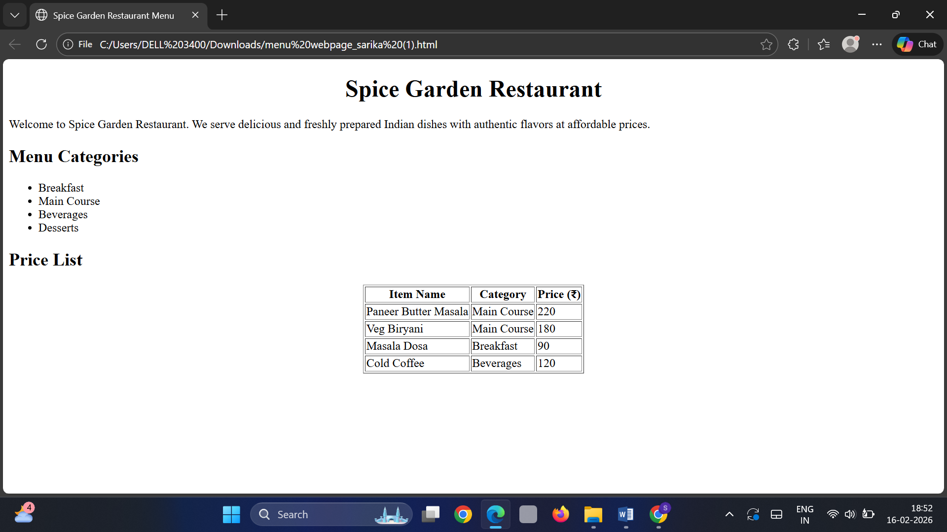
Explanation:
This HTML page is created to design a basic restaurant menu webpage for Spice Garden Restaurant. It uses the proper HTML boilerplate structure including the <html>, <head>, and <body> tags. The restaurant name is displayed using the <h1> heading tag, and the description is written using the <p> tag. The menu categories are shown using an unordered list with <ul> and <li> elements. The price list is displayed using a table created with <table>, <tr>, <th>, and <td> tags. HTML attributes such as border, title, and align are also used as required. This webpage demonstrates the basic structure and usage of important HTML elements.
Problem 3: Personal Grocery Checklist (Level-1)
Scenario
You are building a simple webpage for personal use to plan your weekly grocery shopping. The page should clearly show priority items and optional items, so it’s easy to decide what to buy first.
📌 Requirements
Create an HTML webpage that includes:
- A page title:
Weekly Grocery Checklist
- A main heading displaying the same title.
- An Ordered List showing high-priority grocery items, such as:
  - Rice
  - Milk
  - Vegetables
  - Cooking Oil
- An Unordered List showing optional or non-essential items, such as:
  - Snacks
  - Ice cream
  - Soft drinks

🛠️ Technical Constraints
- Use proper HTML boilerplate:
  - <!DOCTYPE html>
  - <html>, <head>, <body>
- Use:
  - <ol> and <ul> correctly
  - <li> for each item
- Add at least one HTML attribute (example: title)
- Ensure proper indentation and readability

🎯 Learning Outcome
You will be able to:
- Create structured content using HTML lists
- Choose the correct list type based on real-world requirements
- Understand how HTML represents logical order and grouping
- Build confidence in writing basic but meaningful HTML pages
HTML Code:
<!DOCTYPE html>
<html lang="en">
<head>
<meta charset="UTF-8">
<title>Weekly Grocery Checklist</title>
</head>
<body>
<h1 title="My Weekly Shopping Plan">Weekly Grocery Checklist</h1>
<h2>High-Priority Items</h2>
<ol>
<li>Rice</li>
<li>Milk</li>
<li>Vegetables</li>
<li>Cooking Oil</li></ol>
<h2>Optional Items</h2>
<ul>
<li>Snacks</li>
<li>Ice cream</li>
<li>Soft drinks</li></ul>

</body>
</html>

Output:

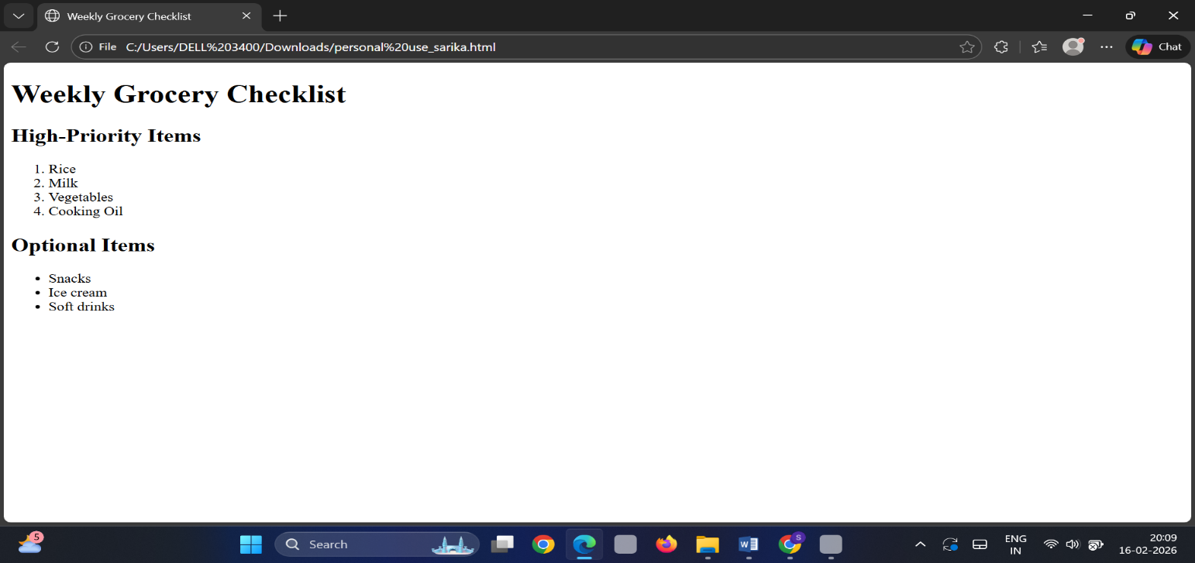

Explanation:
This HTML webpage is created to display a Weekly Grocery Checklist for personal use. It follows the proper HTML boilerplate structure including <!DOCTYPE html>, <html>, <head>, and <body> tags. The page title is set using the <title> tag, and the main heading is displayed using the <h1> tag with a title attribute. High-priority items are shown using an ordered list (<ol>) to represent importance and sequence, while optional items are displayed using an unordered list (<ul>). Each grocery item is written using <li> tags. This webpage demonstrates the correct use of HTML lists and basic page structure in a clear and organized way.
Problem 4: Employee Onboarding Page (Level-2)
Scenario
A company wants a basic onboarding page for new employees that HR can later style using CSS.
📌 Requirements
Use Semantic HTML:
- <header> → Company name & welcome message
- <section> → Employee details
- <article> → Company policies
- <footer> → Contact information
Content Structure
- Employee Information (Table)
  - Employee ID
  - Name
  - Department
  - Joining Date
- Company Policies (Ordered List)
  - Working hours
  - Leave policy
  - Code of conduct
- Facilities Provided (Unordered List)
  - Laptop
  - Internet access
  - Training materials

🛠️ Technical Constraints
- Use semantic tags only (no <div> for layout)
- Add meaningful attributes (title, lang, etc.)
- Proper indentation & readability
🎯 Learning Outcome
Learners should be able to:
- Explain why semantic HTML matters
- Differentiate between structural and non-structural tags
- Build readable, SEO-friendly HTML
HTML Code:
<!DOCTYPE html>
<html lang="en">
<head>
<meta charset="UTF-8">
<title>Employee Onboarding Page</title>
<meta name="description" content="Basic onboarding page for new employees">
</head>
<body>
<header>
<h1 title="Company Name">Cognizant Technologies Pvt. Ltd.</h1>
<p>Welcome to the company! We are excited to have you onboard.</p>
</header>
<section>
<h2>Employee Information</h2>

<table border="1" title="Employee Details Table">
<thead>
<tr>
<th>Employee ID</th>
<th>Name</th>
<th>Department</th>
<th>Joining Date</th>
</tr>
</thead>
<tbody>
<tr>
<td>EMP001</td>
<td>John Doe</td>
<td>Information Technology</td>
<td>16-02-2026</td>
</tr>
</tbody>
</table>
</section>
<article>
<h2>Company Policies</h2>

<ol>
<li>Working hours: 9:00 AM – 6:00 PM</li>
<li>Leave policy: 12 paid leaves per year</li>
<li>Code of conduct: Maintain professionalism and integrity</li>
</ol>

<h3>Facilities Provided</h3>
<ul>
<li>Laptop</li>
<li>Internet access</li>
<li>Training materials</li>
</ul>
</article>
<footer>
<p>Contact HR: hr@cognizanttech.com</p>
<p>Phone: +91-9876543210</p>
</footer>

</body>
</html>
Output:
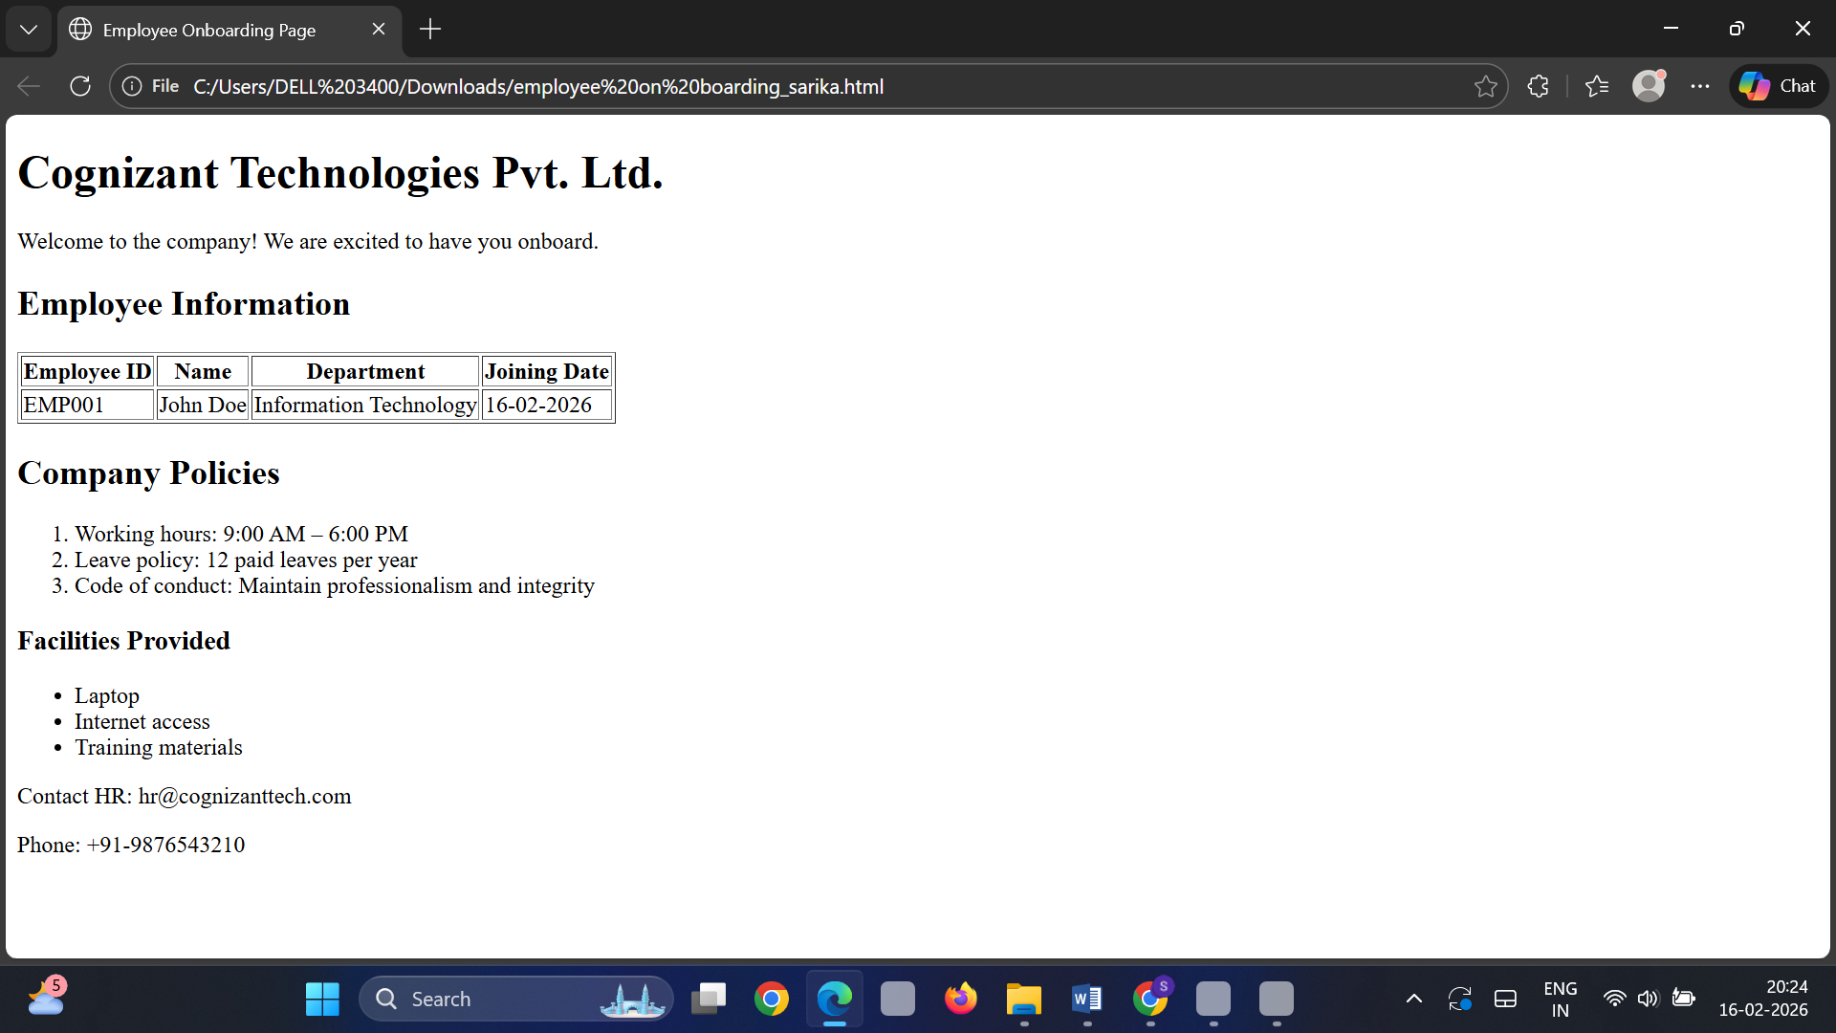
Explanation:
This HTML document is created as an Employee Onboarding Page using semantic HTML elements to provide clear structure and meaning. The <header> section contains the company name and welcome message, introducing the page. The <section> tag is used to display employee information in a structured table format with <table>, <thead>, <tbody>, <tr>, <th>, and <td> elements. The <article> section presents company policies using an ordered list (<ol>) and facilities provided using an unordered list (<ul>). Finally, the <footer> contains the HR contact details. Meaningful attributes such as lang, title, and meta description are included to improve readability and SEO. This webpage demonstrates the importance of semantic HTML in creating well-structured, organized, and meaningful content.
Problem 5: College Department Information Page (Level-2)
Scenario
A college wants to create a basic informational webpage for one of its departments (e.g., Computer Science, Information Technology).
The page will be used by students and parents to understand faculty details, subjects offered, and the weekly timetable before the site is enhanced with CSS and backend features.
📌 Requirements
Create an HTML webpage that includes the following sections:
- Header
  - Department Name
  - College Name
- Section 1: Faculty Details
  - Display faculty information in a table with columns:
    - Faculty Name
    - Designation
    - Subject Handled
- Section 2: Subjects Offered
  - Display the list of subjects using an unordered list
- Section 3: Weekly Timetable
  - Display timetable details in a table with columns:
    - Day
    - Subject
    - Time Slot
- Footer
  - College address
  - Contact information

🛠️ Technical Constraints
- Use proper HTML document structure:
  - <!DOCTYPE html>
  - <html>, <head>, <body>
- Use semantic HTML elements:
  - <header>, <section>, <footer>
- Use:
  - <table>, <tr>, <th>, <td>
  - <ul> and <li>
- Add meaningful HTML attributes such as lang or title
- Avoid CSS and JavaScript (HTML only)
🎯 Learning Outcome
You will be able to:
- Build real-world HTML pages with structured content
- Understand how semantic HTML improves readability and maintenance
- Organize information logically using tables and lists
- Prepare HTML content that is ready for CSS styling and backend integration
HTML Code:
<!DOCTYPE html>
<html>
<head>
<title>Computer Science Department - JNTUK College</title>
<meta charset="UTF-8">
</head>
<body>
<header>
<h1>Computer Science Department</h1>
<h2>JNTUK College of Engineering</h2>
</header>

<hr>
<section>
<h3>Faculty Details</h3>
<table border="1">
<tr>
<th>Faculty Name</th>
<th>Designation</th>
<th>Subject Handled</th>
</tr>
<tr>
<td>Dr. Ramesh Kumar</td>
<td>Professor</td>
<td>Data Structures</td>
</tr>
<tr>
<td>Ms. Anjali Sharma</td>
<td>Assistant Professor</td>
<td>Database Management Systems</td>
</tr>
<tr>
<td>Mr. Suresh Rao</td>
<td>Associate Professor</td>
<td>Operating Systems</td>
</tr>
</table>
</section>

<hr>
<section>
<h3>Subjects Offered</h3>
<ul>
<li>Data Structures</li>
<li>Database Management Systems</li>
<li>Operating Systems</li>
<li>Computer Networks</li>
<li>Software Engineering</li>
</ul>
</section>

<hr>
<section>
<h3>Weekly Timetable</h3>
<table border="1">
<tr>
<th>Day</th>
<th>Subject</th>
<th>Time Slot</th>
</tr>
<tr>
<td>Monday</td>
<td>Data Structures</td>
<td>9:00 AM - 10:30 AM</td>
</tr>
<tr>
<td>Tuesday</td>
<td>Database Management Systems</td>
<td>10:30 AM - 12:00 PM</td>
</tr>
<tr>
<td>Wednesday</td>
<td>Operating Systems</td>
<td>1:00 PM - 2:30 PM</td>
</tr>
<tr>
<td>Thursday</td>
<td>Computer Networks</td>
<td>9:00 AM - 10:30 AM</td>
</tr>
<tr>
<td>Friday</td>
<td>Software Engineering</td>
<td>11:00 AM - 12:30 PM</td>
</tr>
</table>
</section>

<hr>
<footer>
<p><strong>Address:</strong> JNTUK College of Engineering, Hyderabad, Telangana</p>
<p><strong>Contact:</strong> +91 98765 43210 | info@JNTUKcollege.edu</p>
</footer>
</body>
</html>

Output:
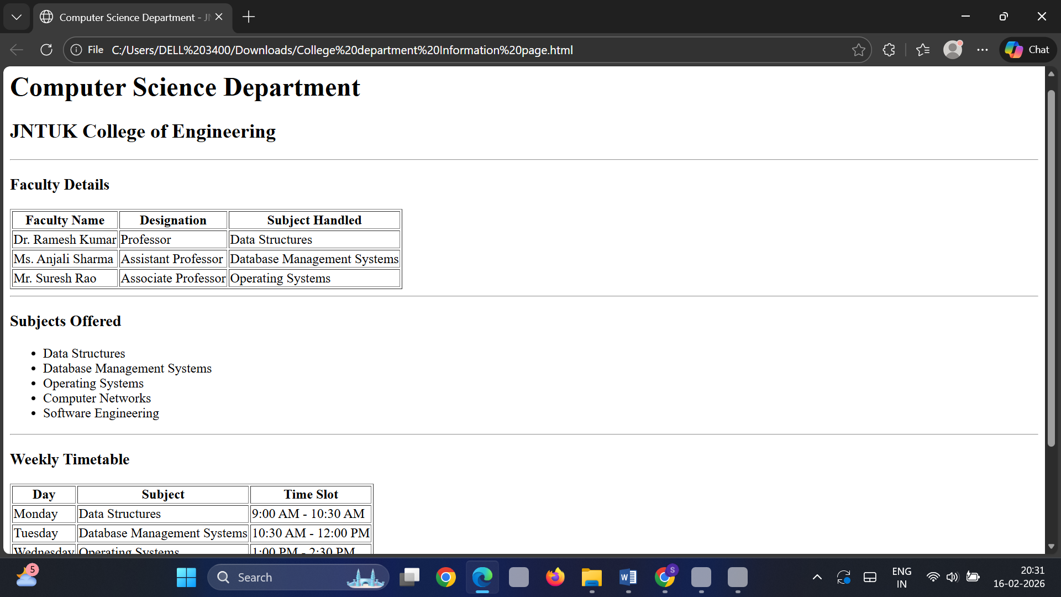
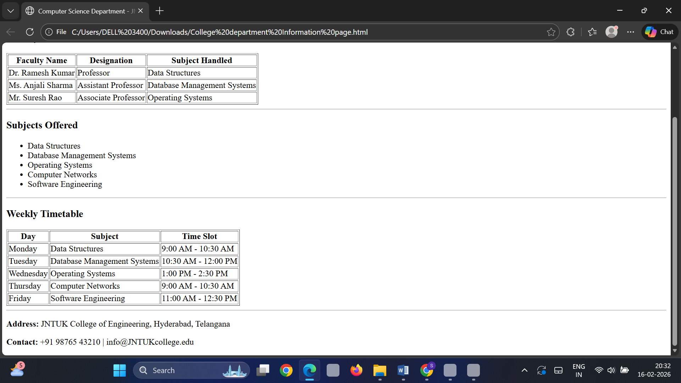
Explanation:
This HTML document is created as a College Department Information Page using proper semantic HTML structure. The page begins with the standard HTML boilerplate including <!DOCTYPE html>, <html>, <head>, <title>, and <meta> tags. The <header> section displays the department name and college name using heading tags, which clearly identify the page. Separate <section> elements are used to organize content such as Faculty Details, Subjects Offered, and Weekly Timetable. The faculty details and timetable are displayed using <table>, <tr>, <th>, and <td> elements to present structured information clearly. The subjects offered are shown using an unordered list with <ul> and <li> elements. Finally, the <footer> section contains the college address and contact information. This webpage demonstrates the use of semantic elements to create a well-structured, organized, and meaningful HTML document.

